**LAB EXERCISE 10**

**Aim: Creating an AWS RDS Instance in Terraform**

Step 1: Create a main.tf file

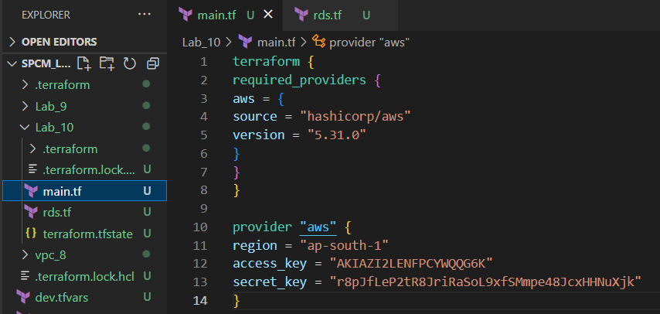

Step 2: Create a rds.tf file

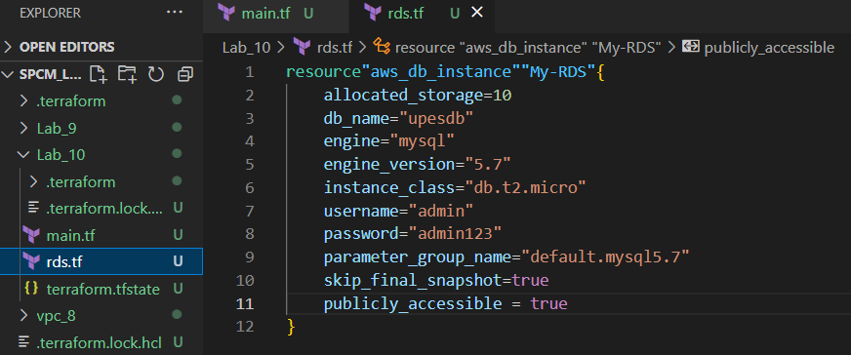

Step 3: Now run terraform init command to Initialize.

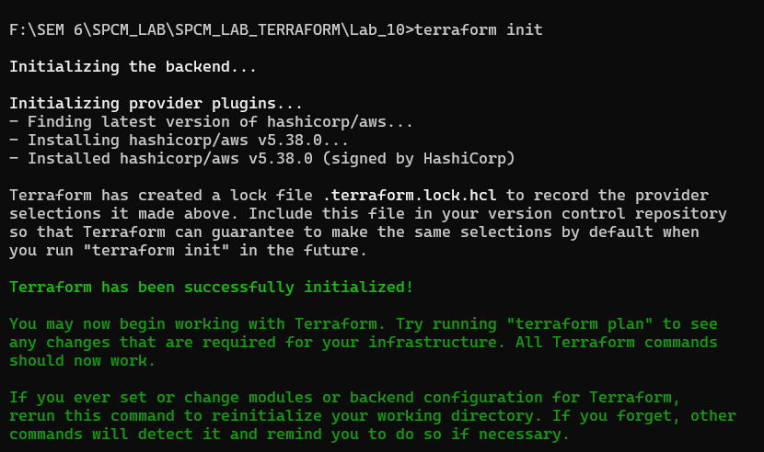

Step 4: Now run the terraform validate command to check if any error is present or not.



Step 5: Now run terraform plan command.

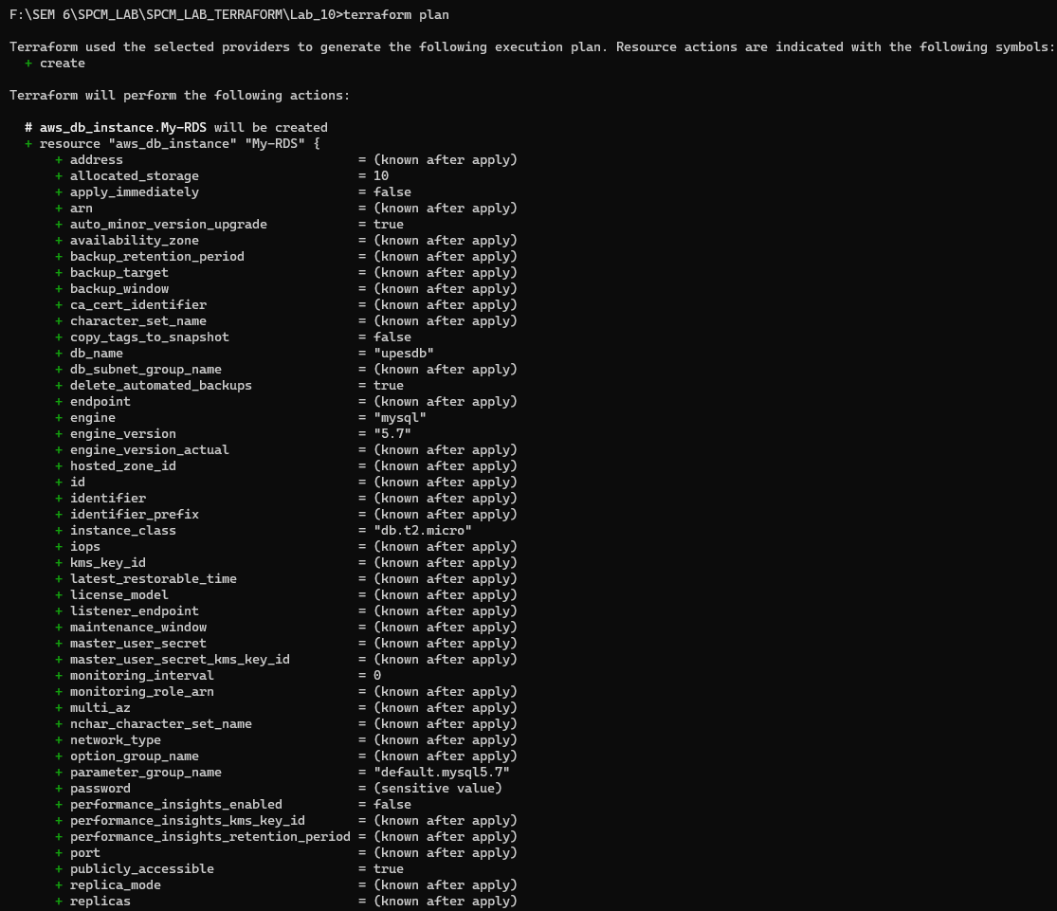

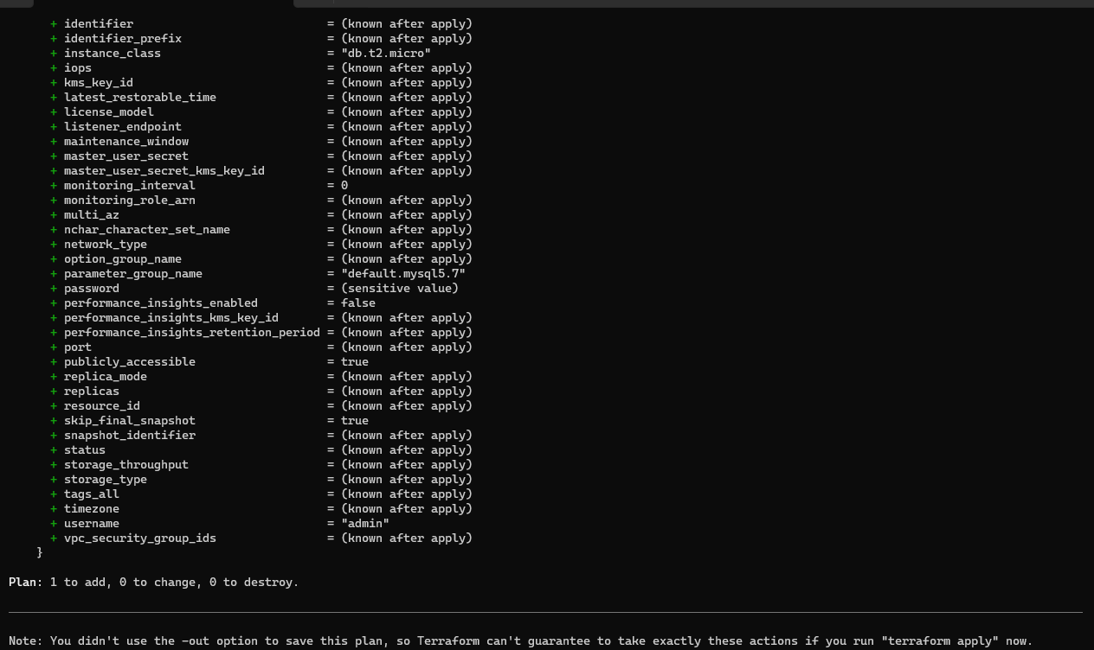

Step 6: Now run the terraform apply command to apply the rds.

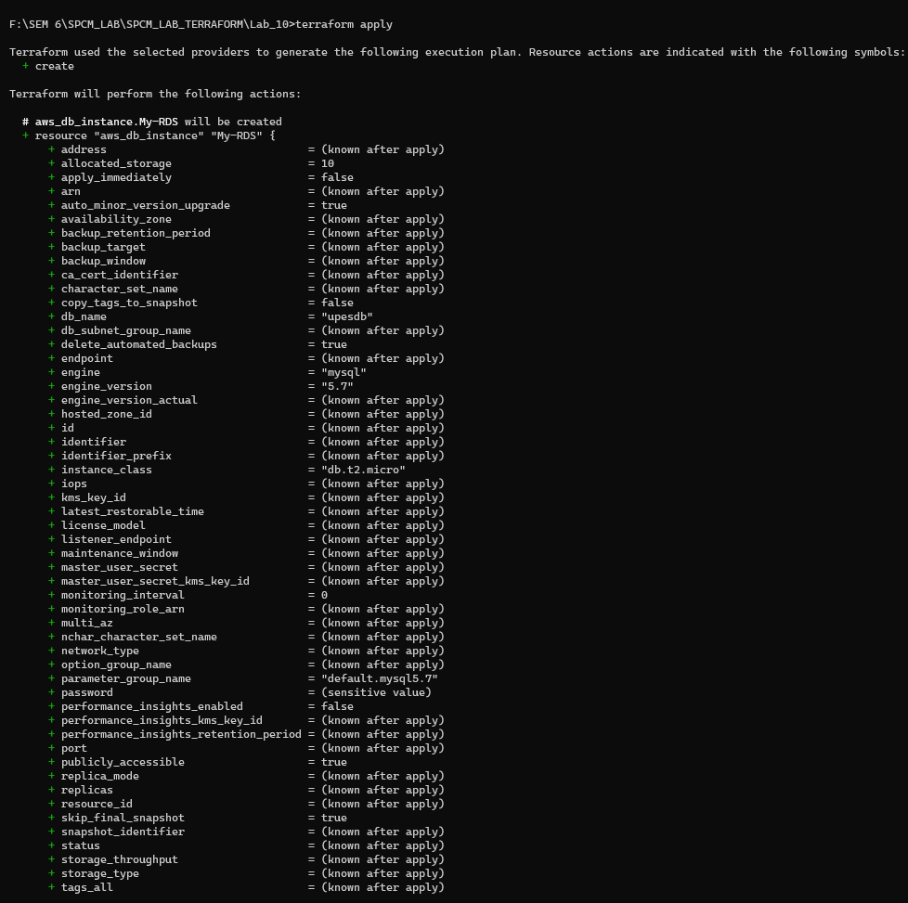

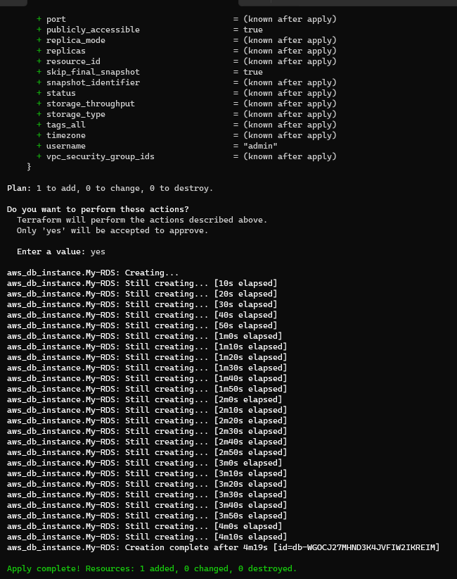

Step 7: Verify the RDS Instance in AWS Console.

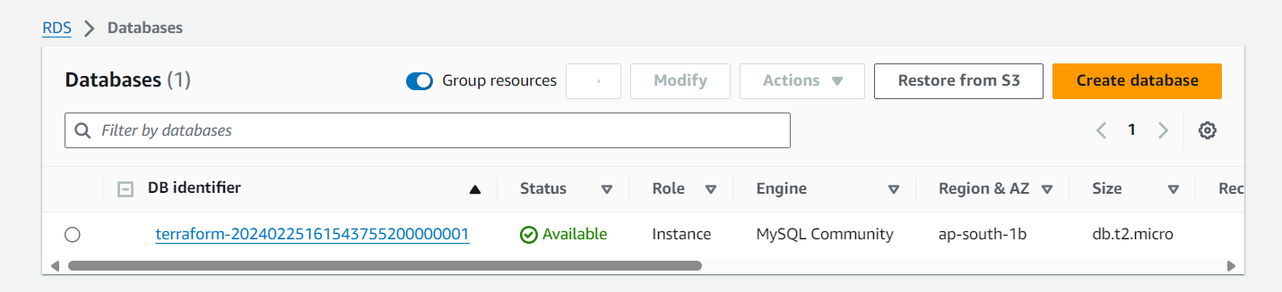

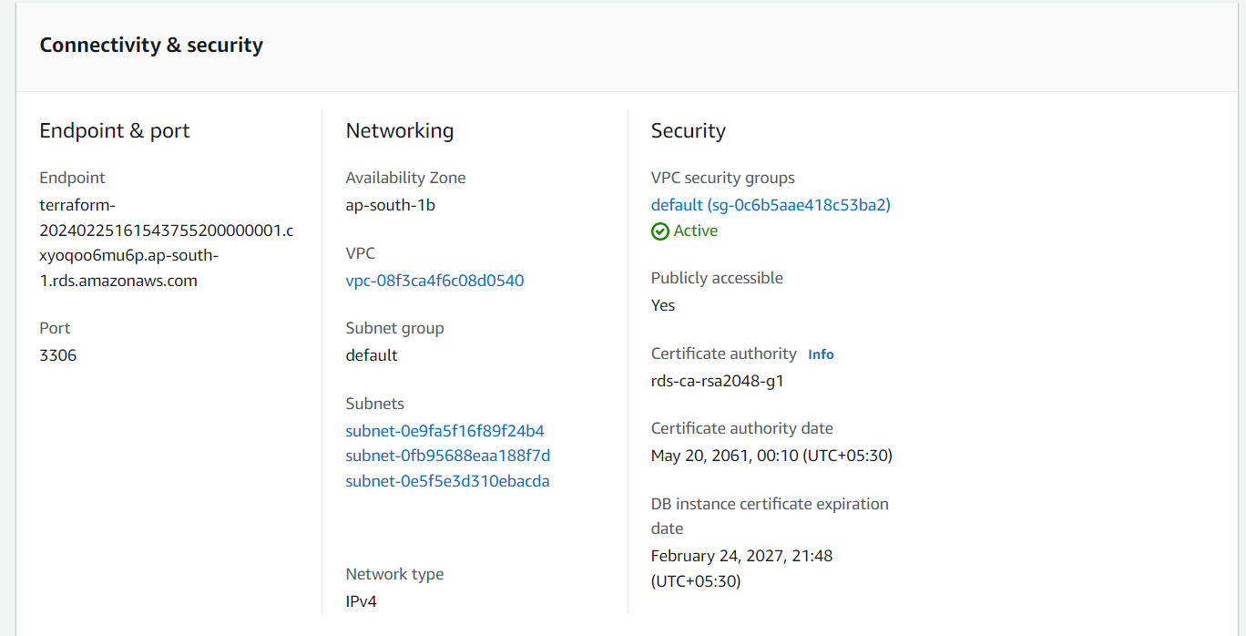

Step 8: Connect To MYSQL Workbench.

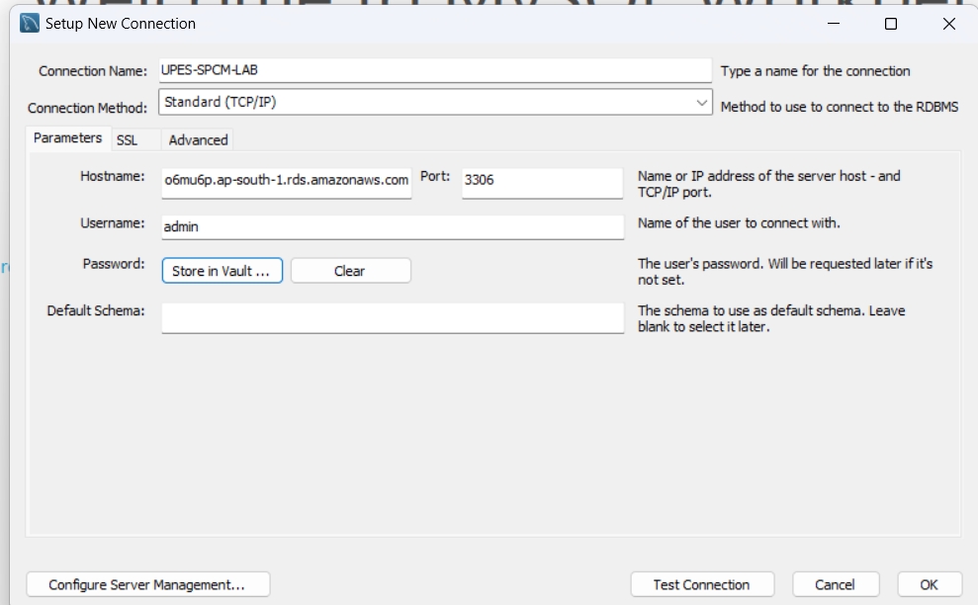

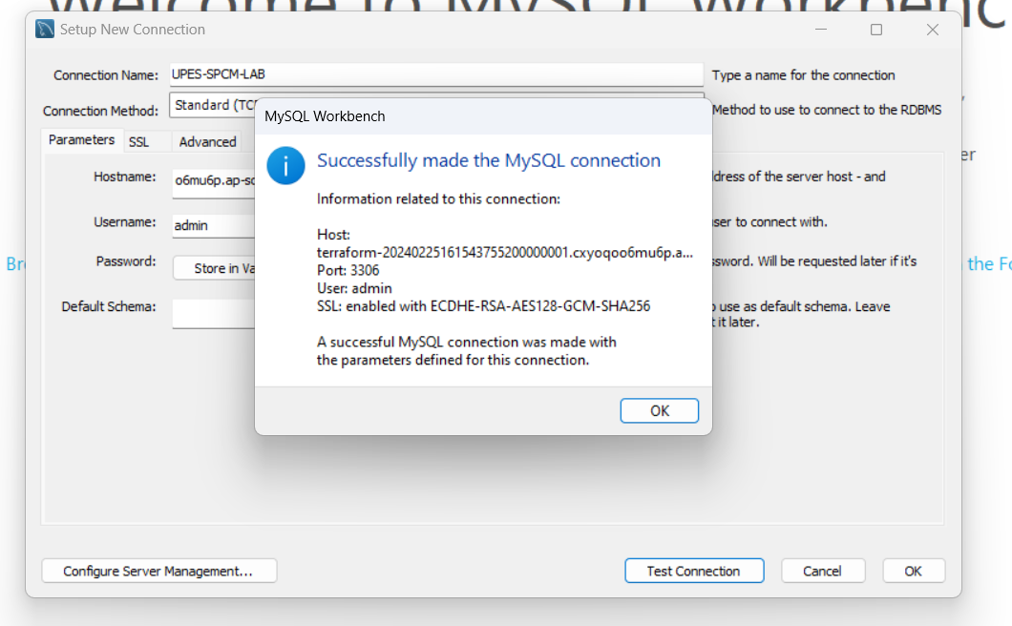

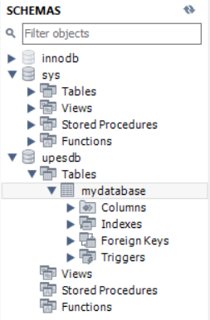

Step 9: Now Destroying the rds created.

